**St. Xavier’s College**

**(Affiliated to Tribhuvan University)**

**Maitighar, Kathmandu**



**COMPUTER GRAPHICS**

**LAB ASSIGNMENT #8**

**IMPLEMENTING REFLECTION IN C++ BUILDER**

**Submitted By**

Victor Kumar Sapkota

013BSCCSIT047

**Submitted To**

|  |  |
| --- | --- |
| Er. Anil K Shah  Lecturer, St. Xavier’s College |  |

Department of Computer Science

Date of Submission: 4th Sep, 2015

**STATEMENT:**

**WRITE A PROGRAM TO IMPLEMENT REFLECTION USING C++ BUILDER.**

**SOURCE CODE**

//---------------------------------------------------------------------------

#include <vcl\vcl.h>

#pragma hdrstop

#include "rot.h"

#include "math.h"

//---------------------------------------------------------------------------

#pragma resource "*.dfm"

int a, b, i, j, x, y;

TForm1 *Form1;

//---------------------------------------------------------------------------

__fastcall TForm1::TForm1(TComponent* Owner)

: TForm(Owner)

{

}

//---------------------------------------------------------------------------

void __fastcall TForm1::RefOriginClick(TObject *Sender)

{

x = Image1->Height;

y = Image1->Width;

for(i=0;i<=x;i++)

{

for(j=0;j<=y;j++)

{

a = -i;

b = -j;

a=a+x;

b=b+y;

Image2->Canvas->Pixels[a][b] = Image1->Canvas->Pixels[i][j];

}

}

}

//---------------------------------------------------------------------------

void __fastcall TForm1::RefXClick(TObject *Sender)

{

x = Image1->Height;

y = Image1->Width;

for(i=0;i<=x;i++)

{

for(j=0;j<=y;j++)

{

a = i;

b = -j;

b=b+y;

Image2->Canvas->Pixels[a][b] = Image1->Canvas->Pixels[i][j];

}

}

}

//---------------------------------------------------------------------------

void __fastcall TForm1::RefYClick(TObject *Sender)

{

x = Image1->Height;

y = Image1->Width;

for(i=0;i<=x;i++)

{

for(j=0;j<=y;j++)

{

a = -i;

b = j;

a=a+x;

Image2->Canvas->Pixels[a][b] = Image1->Canvas->Pixels[i][j];

}

}

}

//---------------------------------------------------------------------------

**OUTPUT SCREEN**

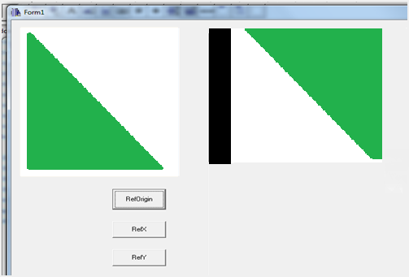

Fig: Reflection about Origin.

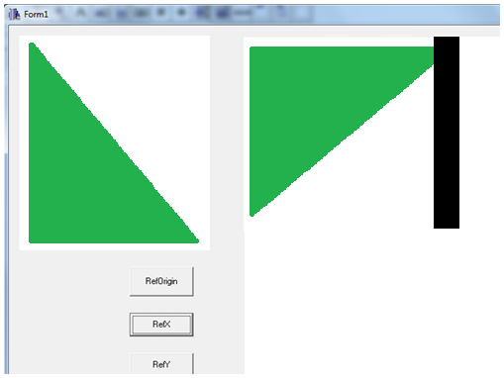

Fig: Reflection about X-axis.

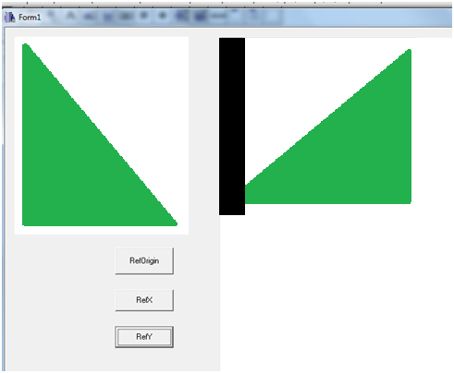

Fig: Reflection about Y-axis.

**Conclusion:**

Reflection was implemented using C++ Builder.